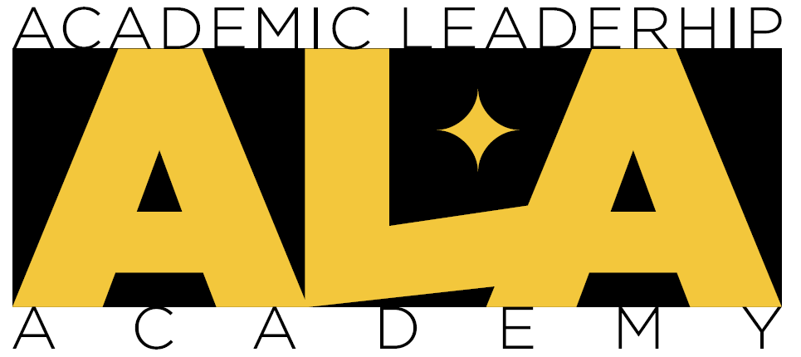
Faculty Excellence
Academic Leadership Academy
2024-2025
Dean/Vice President Endorsement
Applicant’s Name: Click here to enter text.
College: Click here to enter text.
Department/School/Unit: Click here to enter text.
The faculty member named above has applied for the 2024-2025 Academic Leadership Academy. This program will meet once a month on the following dates and times:
Fall 2024 Semester | Spring 2025 Semester
 | TBD
September 6, 2024 9-11:00am
October 4, 2024 9-11:00am
November 1, 2024 9-11:00am
November 22, 2024 9-11:00am

Dean/Vice President Name: Click here to enter text.
Signature: ________________________________________ Date: Click here to enter text.
Please select one of the following:
☐Support ☐ Support With Reservations ☐ Do Not Support

Comments:
Click here to enter text.

Applications (including this form) should be submitted to Faculty Excellence via email to facultyexcellence@ucf.edu by 5:00 p.m. on August 8, 2024, with applicants notified on or before April 19, 2024.

