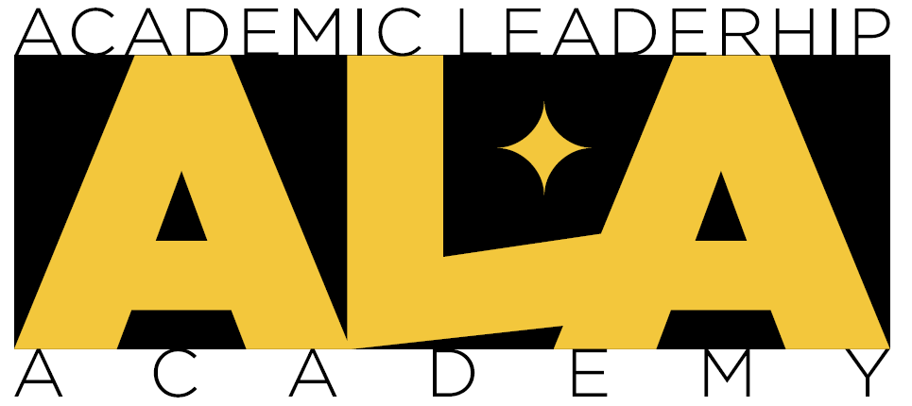
Faculty Excellence
Academic Leadership Academy
2024-2025

Chair/Director Endorsement

Applicant’s Name: Click here to enter text.
College: Click here to enter text.
Department/School/Unit: Click here to enter text.
The faculty member named above has applied for the 2024-25 Academic Leadership Academy. This program will meet once a month on the following dates and times:
Fall 2024 Semester | Spring 2025 Semester
September 6, 2024 9-11:00am | TBD
October 4, 2024 9-11:00am
November 1, 2024 9-11:00am
November 22, 2024 9-11:00am

As the Chair/Director of the applicant, please provide Faculty Excellence with your recommendation for this applicant to participate in the leadership program.
- I rank this applicant’s career leadership potential as:
☐ Excellent ☐ Above Average ☐ Average

- Does this applicant have the time to participate in a monthly leadership program?
☐ Yes ☐No

- Any Concerns to Note:
Click here to enter text.
Chair/Director Name: Click here to enter text.
Signature: ________________________________________ Date: Click here to enter text.
Please select one of the following:
☐Support ☐ Support with Reservations ☐ Do Not Support

Applications (including this form) should be submitted to Faculty Excellence via email to facultyexcellence@ucf.edu by 5:00 p.m. on August 8, 2024, with applicants notified on or before August 19, 2024.

